

**A R T I S T S T A T E M E N T**

What attracts me to my work is the dichotomy that exists between materials and processes. The Wildness of forging juxtaposed with elegant goldsmithing techniques. I am interested in the underlying tension that results from combining disparate materials such as steel and diamonds or gold and steel, in organic forms. My hope is that my work will go out into the world and communicate for me.

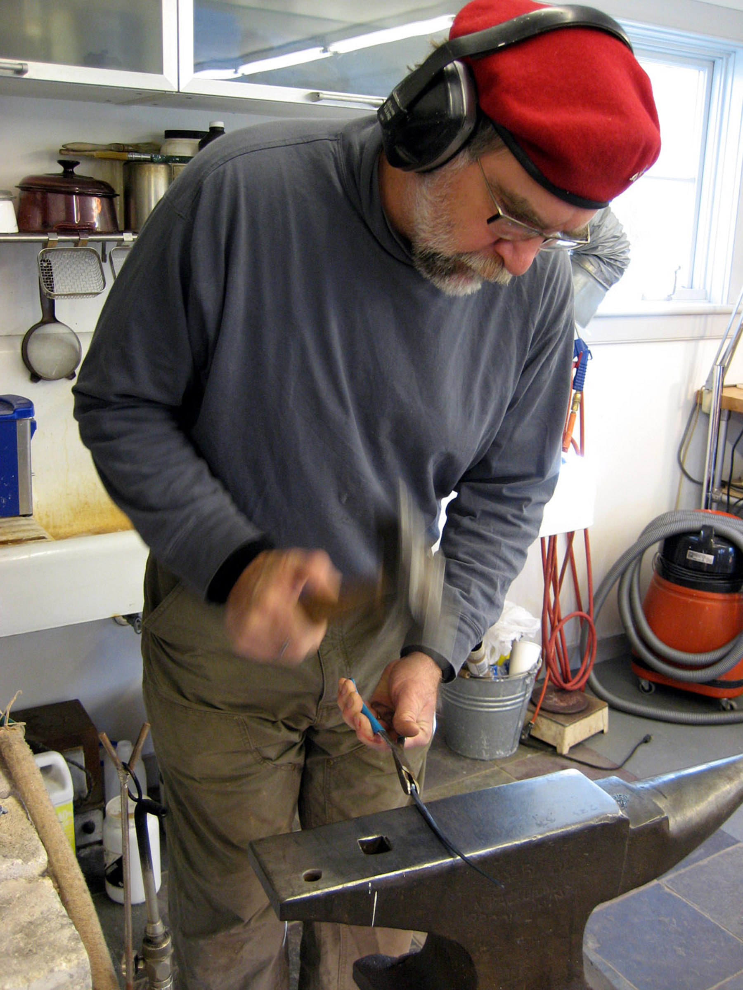

**B I O G R A P H Y**

Pat Flynn is a goldsmith who lives and works in High Falls, New York. He was born in Edinboro, PA. Pat is known for both his elegant bracelets and necklaces that combine blackened steel with 22k, 18k, platinum, diamonds and pearls; and, for his meticulous hinges and latches. His work has been featured in “metalsmith” magazine and, most recently included in the Penland Book of Jewelry. His work can also be found in the collections of the Renwick Gallery of the Smithsonian Institute, the Art Institute of Chicago, and the Museum of Art & Design in New York. His work has most recently been acquired by the Museum of Fine Arts, Boston and the Metropolitan Museum of Art, NYC.