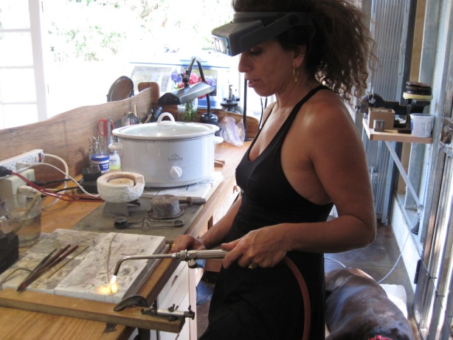S*tudio*22k

Paia,Maui

Sherri Dhyan’s mission is to encourage and perpetuate the ancient art of hand fabricated 22 karat gold jewelry.

Studio 22k is a show case for jeweler Sherri Dhyan and 22 karat goldsmiths from around the world.

*Originally from NYC, I began my formal studies of fine art, contemporary and ancient jewelry in 1981. I studied at Parsons School of Design, The Jewelry Arts Institute in NYC and worked on the bench of 47th street. I apprenticed with various jewelry designers and gold smiths before traveling to Japan and South East Asia for 4 years. In 1997 I set up my first open jewelry studio in Upcountry Maui, Hawaii. On March 1st 2012 Studio22k opened its doors in Paia, Maui. Expanding into a 22 karat jewelry gallery and workshop where I can host and support the craft of handmade 22 karat gold jewelry has been my dream come true.*

*-Sherri Dhyan*

Ancient and contemporary techniques meld together in this beautiful setting of both working studio and gallery. We are the only studio/ gallery featuring handmade 22k gold jewelry in Hawaii. Visitors can witness the creation from raw materials to fine works of jewelry art.

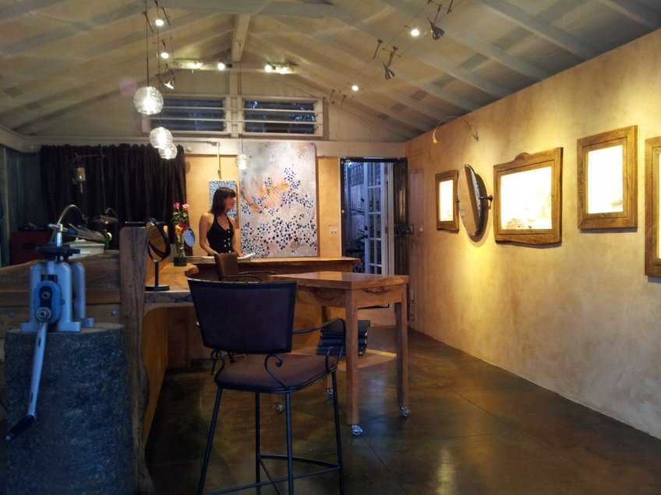At Studio 22k each piece of jewelry is hand fabricated. One of a kind jewelry made of the purest gold, and best stones provides clients unique and valuable jewelry. Sherri designs with the characteristics of high karat gold in mind. The matt, hammered finish of her jewelry enhances the natural wear of everyday life. Her jewelry looks and feels ancient.

Studio22k has been on Maui for 15 years nestled in the hills of Keokea up country Maui. The new Paia location is an exciting expansion that offers visitors a unique opportunity to publicly view Sherri’s goldsmith process. We welcome meeting you in the studio during your next visit to Paia!

**161B Hana Hwy (just before the Paia Fire Station) Paia, HI 96779 (808) 579-8167 www.Studio22k.com**

009.tif 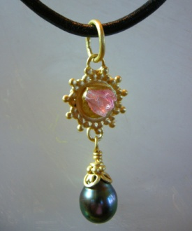_MG_3945.tifRubyOm1.jpg_86Y7925.tif